

Mechatronics system design

24EARC302

Project report on

**NextGenCart:Shopping Made Smart and Simple**

Submitted to the Department of Automation & Robotics of the KLE Technological University in partial fulfillment of the requirements for the degree of

**Bachelor of Engineering**

in

**Automation & Robotics**

Submitted by

|  |  |
| --- | --- |
| Shrinidhi Mudhole | 01fe22bar015 |
| Nandeesh B Tuppad | 01fe22bar020 |
| Vijay Totakar | 01fe22bar023 |
| Shwetha S Halepujari | 01fe22bar042 |
| Koushik | 01fe23bar413 |

Under the guidance of

**Dr. Vinodkumar Meti**

**Assistant Professor**

**Dept of Automation & Robotics**

2024-2025



**KLE TECHNOLOGICAL UNIVERSITY**

**DEPARTMENT OF AUTOMATION & ROBOTICS**

**Certificate**

This is to certify that Mechatronics system design - Project report entitled NextGenCart:Shoppping made smart and simpleis a bonafied work carried out by Shrinidhi Mudhole, Nandeesh B Tuppad, Vijay Totakar, Shwetha S Halepujari, and Koushik Kamble in partial fulfillment for the award of degree of Bachelor of Engineering in Automation & Robotics of KLE Technological University, Hubballi during the year 2023-2024.

|  |  |
| --- | --- |
|  | Guide  Designation |

**External Viva**

|  |  |
| --- | --- |
| Name of the Examiner | Signature with Date |
|  |  |
|  |  |

# ACKNOWLEDGMENTS

We would like to thank the KLE Technological University for providing an opportunity and pedagogical improvement which helped us to get a hands-on experience in the 5th semester level.

We would thank our HOD, Prof. Sachin Karadgi for the competitive changes in curriculum and keeping the course content updated as per the industry requirement and standards.

We would thank our guide Dr. Vinodkumar Meti for his involvement and guidance throughout the course.

We would provide our heartly thanks to the faculty in-charge, Mr. Prashant Udapudi & Mr. Vinayak Khatawate for their continuous involvement, assigning challenging tasks and quite an ease of delivery of content. The examples taken up in-session were easy to understand and practice, demonstrated all the tools required for the project fulfillment.

We thank all the staff members of A&R, our parents and teammates for the support and blissful guidance.

# ABSTRACT

NextGenCart: Shopping Made Smart and Simple

**Abstract**

This project presents a Smart Shopping Cart with Automatic Billing, designed to enhance the shopping experience by automating item detection, billing, and navigation. Following the VDI 2206 methodology, the system is developed using a modular and structured approach, ensuring scalability and adaptability. The Smart Shopping Cart is an innovative solution designed to enhance the retail shopping experience through automation and smart technology. This cart autonomously follows the customer without requiring manual pushing, utilizing a mobile application for motion control. It integrates an automatic billing system, which employs an RFID reader module and RFID tags to scan item barcodes, ensuring seamless checkout. The cart automatically identifies products, updates the total cost in real time, and eliminates the need for manual checkout. It also features intelligent navigation, obstacle detection, and user alerts for seamless operation. By reducing checkout time and enhancing convenience, this system improves shopping efficiency. By leveraging Internet of Things (IoT) and automation, this project aims to improve shopping convenience, reduce checkout time, and enhance accessibility for diverse customers, including the elderly and disabled. Future advancements will focus on increased automation, adaptive functionality, and improved user experience.

**TABLE OF CONTENTS**

Page

ACKNOWLEDGMENTS iii

ABSTRACT iv

LIST OF TABLES vii

LIST OF FIGURES viii

1. INTRODUCTION 1

1.1. Introduction 1

1.2. Second Sub-Section 1

2. PROBLEM DESCRIPTION 3

2.1. Figures 3

2.2. Tables 3

3. LITERATURE REVIEW 5

3.1. Topic 1 5

3.1.1. Sub-topic 1 5

3.1.2. Sub-Topic 2 5

3.2. Topic 2 6

4. METHODOLOGY 7

4.1. Topic 1 7

4.2. Topic 2 7

5. IMPLEMENTATION AND VALIDATION 8

5.1. Topic 1 8

5.2. Topic 2 8

6. CONCLUSIONS AND FUTURE WORK 9

6.1. Conclusions 9

6.2. Future Work 9

BIBLIOGRAPHY 10

# LIST OF TABLES

Table Page

Table 2-1 : Lots of Numbers

# LIST OF FIGURES

Figure Page

Figure 2-1 : First Figure with a Long Caption to Show How to Handle Long Captions in the Document and the List of Figures

# INTRODUCTION

In today’s fast-paced world, automation and smart technology have significantly transformed various industries, including retail. Traditional shopping carts require manual pushing, which can be inconvenient for customers, especially the elderly, disabled individuals, and pregnant women. To address these challenges, we have developed the **Smart Shopping Cart,** an autonomous cart that follows the customer without manual effort and integrates an **automatic billing system** for a seamless shopping experience.

The **Smart Shopping Cart** is designed to enhance convenience and efficiency in supermarkets by reducing the time spent at checkout counters and minimizing human effort. It employs an **RFID reader module** and **RFID tags** to scan items, with the total bill displayed on an **LCD screen**. Motion control is managed via a **mobile application**, allowing users to navigate the cart effortlessly. The system is powered by a combination of **DC geared motors**, a **motor driver**, a **9V battery**, and a **Li-ion battery** with a **buck converter** for power regulation. Additionally, an **ultrasonic sensor** ensures obstacle detection and avoidance, making the cart safe for operation in crowded environments.

The motivation behind this project stems from the need for a more **accessible, efficient, and automated shopping experience**. With the integration of **Internet of Things (IoT)** and **automation**, this project aims to revolutionize retail shopping by providing an innovative solution that enhances customer convenience and reduces operational inefficiencies. By eliminating the need for manual cart handling and streamlining the billing process, the Smart Shopping Cart contributes to the future of smart retail.

With the rise of **automation and smart technology**, various industries are adopting intelligent solutions to improve efficiency and user convenience. The retail sector, in particular, faces challenges such as long checkout queues, manual cart handling, and inefficient billing processes. To enhance the shopping experience, **autonomous systems** and **IoT-based solutions** are being integrated into retail environments.

The **Smart Shopping Cart** is designed to revolutionize traditional shopping by incorporating **automation, mobility, and self-billing features**. By reducing manual effort and streamlining the checkout process, this system enhances efficiency, improves accessibility for all customers, and minimizes human intervention in shopping operations.

**1.1 Motivation**

Traditional shopping methods often involve long checkout lines, manual barcode scanning, and difficulties in handling carts, leading to inconvenience for customers. These inefficiencies are particularly challenging for elderly individuals, carrying women, and people with disabilities, who require a more accessible shopping experience. With advancements in automation and smart technologies, there is a growing need to enhance retail efficiency, reduce human effort, and improve customer convenience. A smart shopping cart that automates item detection, billing, and navigation can significantly improve the shopping experience while optimizing store operations.

**1.2 Background**

The retail industry is rapidly evolving with the adoption of IoT, AI, and automation, aimed at making shopping more efficient and customer-friendly. Many stores are implementing self-checkout kiosks and automated payment systems to reduce wait times. However, these solutions still require manual scanning and checkout interactions. The Smart Shopping Cart builds on these advancements by integrating real-time billing, automated movement, and intelligent navigation, ensuring a seamless shopping experience. By leveraging modern technology, this system enhances convenience, improves accessibility, and reduces the dependency on traditional checkout processes.

# PROBLEM DESCRIPTION

### ****NextGen Cart – Shopping made smart and simple****

Traditional shopping experiences often involve long checkout queues, manual barcode scanning, and difficulties in managing purchases, leading to inefficiencies and customer dissatisfaction. Shoppers frequently face challenges such as slow billing processes, difficulty in tracking total expenses, and the inconvenience of pushing heavy carts. These issues are particularly problematic for elderly individuals, carrying women, and disabled customers, who require a more accessible and effortless shopping experience. Additionally, unauthorized item removal and misadded products contribute to errors, making the checkout process more time-consuming and frustrating.

To address these challenges, an automated smart shopping cart is needed to eliminate manual scanning, streamline the billing process, and enhance navigation within the store. By integrating RFID-based item detection, real-time billing, obstacle detection, and mobile app synchronization, the proposed system aims to provide a seamless, user-friendly, and efficient shopping experience. This smart cart will reduce human intervention, optimize store operations, and improve accessibility, making shopping faster, more convenient, and technologically advanced.

# LITERATURE REVIEW

* 1. **Paper 1-**

A new automated smart trolley cart system for modern shopping centres

This paper presents an autonomous shopping cart designed to enhance the shopping experience by eliminating the need to push trolleys and manually sort bills. The cart follows customers automatically, bills items using RFID tags, and prompts payment while updating a local database via nRF24 wireless transceivers. It integrates a Raspberry Pi, a camera, and DC motors for autonomous movement, along with XAMPP for database management. Experimental tests confirm the cart’s ability to accurately follow users within a shopping mall. The system aims to improve convenience, especially for the elderly, disabled, and pregnant customers, contributing to the future of automated shopping.

**3.2 Paper 2-**

RFID based smart trolley for supermarket automation

This paper presents a supermarket automation system using an RFID-based smart trolley. The trolley is equipped with an RFID reader and electronic hardware to streamline the shopping process. When an RFID-tagged item is scanned, its price is added to the total and displayed on an LCD screen. The trolley can locate racks based on LCD instructions and allows item removal, updating the total cost accordingly. An alarm signals if the total cost exceeds a preset budget. Wireless communication via a Zigbee network updates billing information in real time, making checkout faster and more efficient.

**3.3 Paper 3-**

Smart Shopping Cart with Automated Billing System

This paper discusses a Smart Shopping Trolley that integrates an RFID-based automatic billing system to reduce checkout time in supermarkets. Instead of traditional barcodes, each product has an RFID tag, which is scanned when placed in the trolley. The trolley features an RFID reader, LCD module, and a microcontroller to display product details and calculate the total bill. Once shopping is complete, the bill is stored in the microcontroller and sent to the customer via a GSM module. The system is programmed using Arduino IDE and simulated in Proteus before hardware implementation.

* 1. **Paper 4-**

Smart Shopping Trolley Using RFID Based on IoT

This paper presents a Smart Shopping Cart system designed to automate navigation and billing in shopping malls. The cart features a robotic structure controlled via a keypad for movement, which also includes a built-in barcode reader to scan product details. An LCD displays the scanned items and prices, while a wireless billing system using Wi-Fi ensures seamless transactions. Additionally, a load cell detects unscanned items based on weight, triggering an alarm for unauthorized additions. This system aims to reduce long queues at billing counters, improving the shopping experience.

**3.5 Paper 5-**

Developing a Multitasking Shopping Trolley Based On RFID Technology

This paper discusses the development of a multitasking shopping trolley using RFID technology to improve the shopping experience by reducing checkout time. The proposed system consists of three key components: Server Communication Component (SCC) for connecting the cart to the main server, User Interface and Display Component (UIDC) for customer interaction, and Automatic Billing Component (ABC) for handling transactions. The smart cart, equipped with RFID, automatically identifies purchased items and updates the bill in real time. The system aims to be cost-effective, scalable, and efficient, streamlining the shopping process and eliminating long checkout queues.

.

# METHODOLOGY

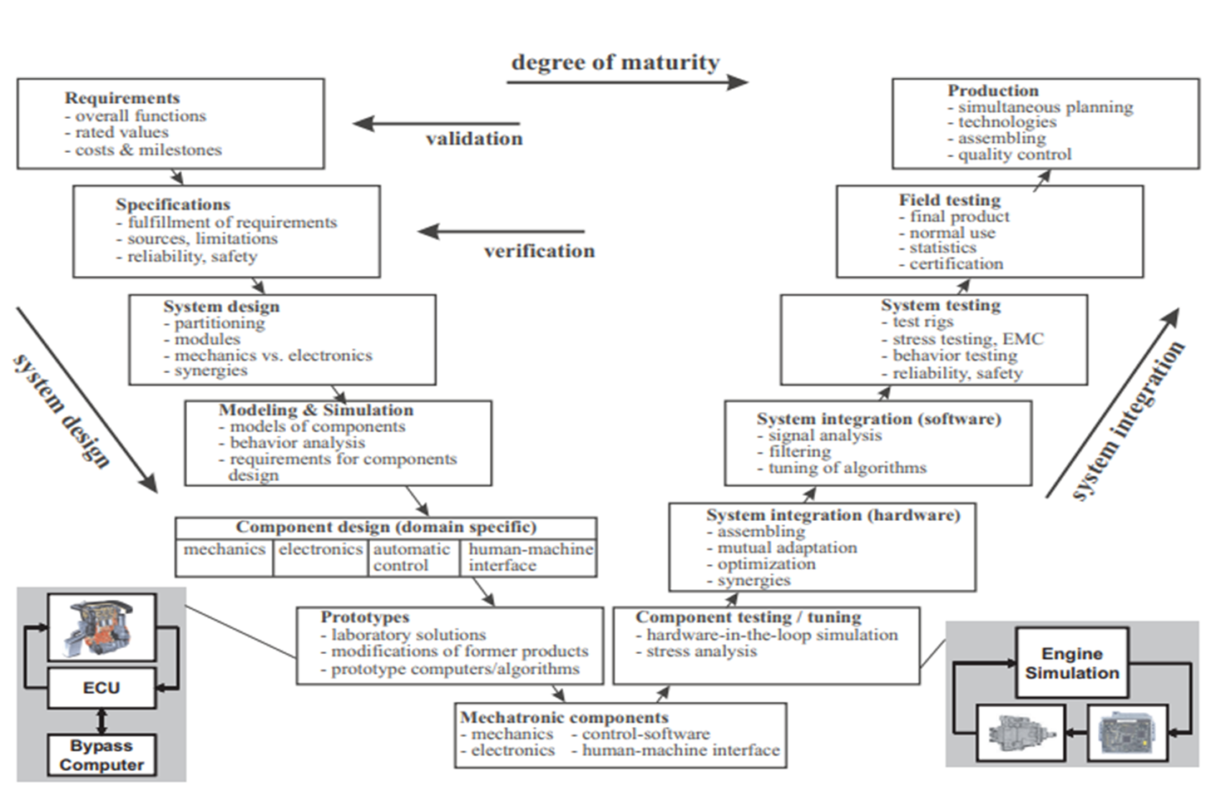

This VDI 2206 V-Model illustrates the mechatronic system development lifecycle, from requirements and design to integration, testing, and production. It covers modeling, simulation, component design, and prototyping, followed by hardware/software integration, system testing, and field validation. Key elements include ECU (electronic control unit), Bypass Computer, and Engine Simulation for real-time testing.

* 1. **Requirements collection**
* **Requirements Definition:**
* The **Smart Shopping Cart** aims to enhance shopping convenience by automating cart movement and integrating a self-checkout system. It should **autonomously follow the customer**, ensuring hands-free navigation, and include a **smart billing system** to reduce checkout time.
* The cart must feature **obstacle detection** for safe movement in crowded spaces and be **controlled via a mobile application** for user convenience. It should ensure **efficient power management** for continuous operation and **real-time bill tracking** for transparency.
* The system should be **user-friendly, reliable, and scalable**, allowing integration with store infrastructure while improving efficiency and accessibility for all customers.

### ****Stakeholder Requirements****

* Safe Distance Maintenance (Safety Block): The cart must maintain a safe distance from the customer to prevent accidental collisions and ensure smooth movement without interruptions.
* Hassle-Free Shopping Experience (Shopping Block): The system should enhance customer convenience by eliminating the need for manual pushing and automating the billing process, reducing waiting times at checkout.
* Reduced Checkout Time: The automatic billing system should minimize queues at the checkout counter by processing payments within seconds.
* User-Friendly Interface: The LCD display should provide a clear, intuitive, and interactive billing summary for ease of use.
* **Functional Requirements**
* Item Detection and Billing (Item_detection_Block): The system should automatically scan and bill the items added to the cart.
* Automatic Item Identification: Each product should be detected as soon as it is placed in the cart.
* User Alerts and Notifications (User_Alert_Block): The system should provide alerts for important events.
* Repeated Item Notification: If the same item is scanned multiple times, the system should notify the user.
* Item Removal Detection: The system should detect and update the bill if an item is removed.
* Safe Distance Maintenance: The cart should maintain a safe distance from the customer while following.
* **System Requirements**
* User Alerts and Notifications : Notifications should be provided for unauthorized item removal or safety issues.
* Unauthorized Item Removal Alert: If an item is removed without proper scanning, an alert should be triggered.
* Large, Clear Display: The LCD should be clear and easy to read for better user experience.
* Organized Wiring: The system should have neatly arranged wiring for safety and maintenance.
* **Performance Requirements**
* Item Detection and Billing: The system should process item scanning and billing in real-time.
* Real-Time Billing: The bill should update instantly as items are added or removed.
* Energy and Efficiency: The cart should optimize power usage while maintaining performance.
* User Interface and Design: The user interface should be interactive and responsive.
* **System Technical Requirements**
* Structural and Design Considerations: The cart should have a strong but lightweight frame.
* Compact and Stable Design: The structure should ensure balance and easy movement.
* Durable Materials: The cart should be built with long-lasting materials for extended use.Writing specifications

## Writing specifications

**Specifications for Smart Shopping Cart**

1. **System Overview**  
   The Smart Shopping Cart is an automated, IoT-based solution designed to enhance the shopping experience by reducing checkout time and improving convenience. It uses RFID technology for automatic item identification, real-time billing, and autonomous navigation. The cart integrates sensors for obstacle detection, a mobile app for remote control, and a real-time display for billing and alerts. The system is designed to be user-friendly, accessible, and energy-efficient, catering to a variety of shoppers, including the elderly, carrying women, and disabled individuals.
2. **Hardware Specifications**

* Microcontroller: ESP32 or equivalent for handling data processing and communication.
* RFID Reader: For detecting tagged items and updating the bill in real-time.
* Sensors: Ultrasonic sensors for obstacle detection and IR sensors for unauthorized item removal alerts.
* Motors: DC motors for autonomous cart movement.
* Display: LCD or LED screen for real-time bill display and notifications.
* Power Supply: Rechargeable batteries with power-efficient components for long operation time.
* Mobile App Interface: For real-time tracking, alerts, and manual cart control.

1. **Software & Algorithm Specifications**

* RFID System: Software that interacts with the RFID reader to identify products as they are placed in the cart, updating the real-time total cost.
* Navigation Control Algorithm: Uses data from ultrasonic sensors to allow the cart to autonomously avoid obstacles and follow the user.
* Mobile Application: An Android or iOS app that syncs with the cart to provide real-time updates, alerts, and the ability to control the cart remotely.
* Billing and Payment System: Software that calculates the total cost and processes payments (through QR code scanning or integration with a digital wallet).
* Error Handling: Algorithm that identifies unauthorized item removal and misadded products, providing real-time alerts to users.

1. **Operational Specifications**

* Navigation: The cart must be capable of autonomously following the user and avoiding obstacles using ultrasonic and IR sensors.
* Billing: Items must be detected automatically, with real-time updating of the total bill on the cart’s display.
* Battery Life: The cart must support at least 8 hours of continuous operation on a single charge.
* Speed: The cart should be able to match the average walking speed of a shopper.
* Alert System: Immediate alerts on the display or through the mobile app for unauthorized item removal, out-of-range movement, and low battery.
* User Interface: A simple and intuitive mobile app interface for controlling the cart, setting a budget, and tracking items.

1. **Testing & Calibration**

* RFID Accuracy Testing: Ensure that items are accurately detected when placed in the cart, with minimal read errors.
* Obstacle Detection Testing: Test ultrasonic sensors for effective obstacle detection and navigation in different store environments.
* Battery Testing: Evaluate battery performance under typical usage conditions to ensure that the cart operates for the required time period.
* Navigation Testing: Ensure the cart can autonomously follow a shopper without colliding with obstacles or straying too far.
* App Integration Testing: Verify that the mobile app syncs correctly with the cart and provides real-time updates and alerts.
* Load Testing: Ensure the cart can carry a variety of products without tipping or affecting its movement.

1. **Compliance & Safety**

* Safety Regulations: Comply with relevant safety standards, including EMC (Electromagnetic Compatibility) and electrical safety to ensure the cart’s safe operation in commercial environments.
* Data Privacy: Ensure that customer data (such as purchase history) is protected and complies with GDPR and other data protection regulations.
* User Safety: The cart will feature smooth edges, non-slip wheels, and secure housing for electronics to prevent injury or damage. The cart will also include an emergency stop feature to prevent accidents.
* Environmental Impact: Use sustainable and recyclable materials in the construction of the cart and ensure that the system is energy-efficient to minimize its environmental footprint.

## 4. 3 Matlab Requirement Toolbox

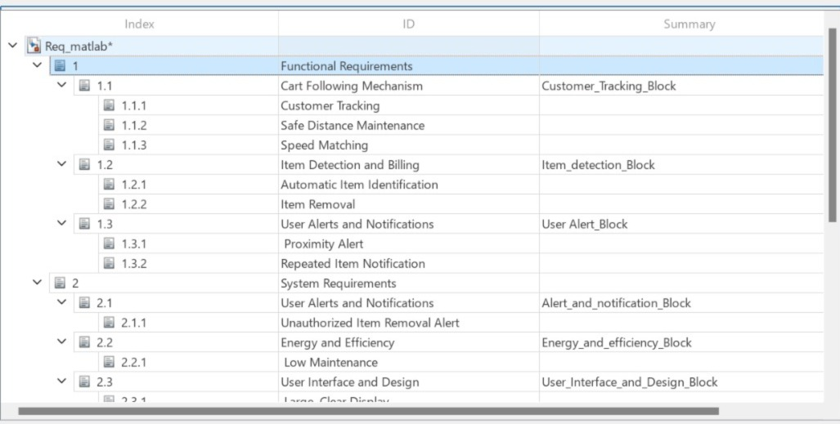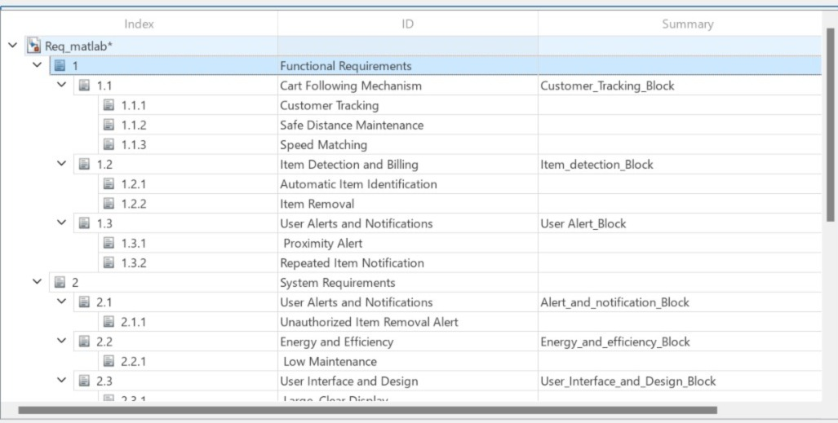

## 4. 4 Conceptual Design

# 

## 4. 5 Function Tree

# 

## 4. 6 FBS Model

# 

## 4. 7 Virtual Model

# 

# 

# 5. IMPLEMENTATION AND VALIDATION

**5.1 Multidisciplinary Product Decomposition and Structure Analysis**

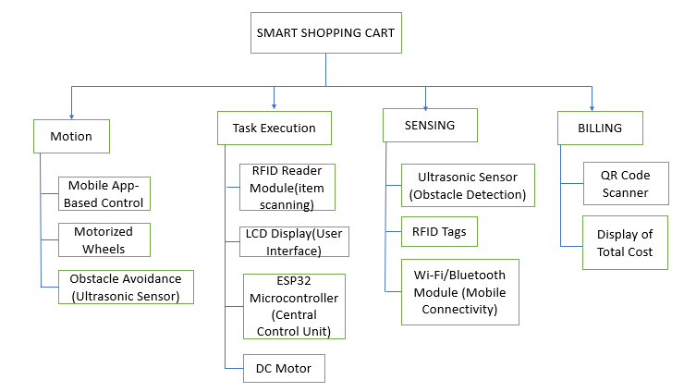

**5. 2 System composer logical architecture**

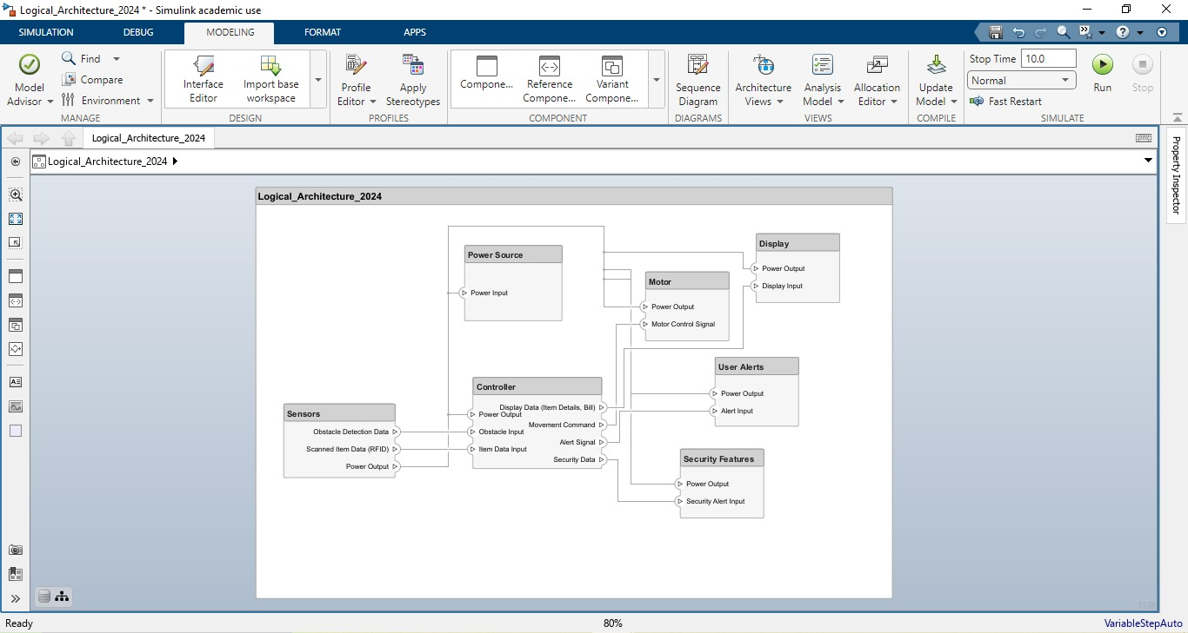

**5.3 System composer functional architecture**

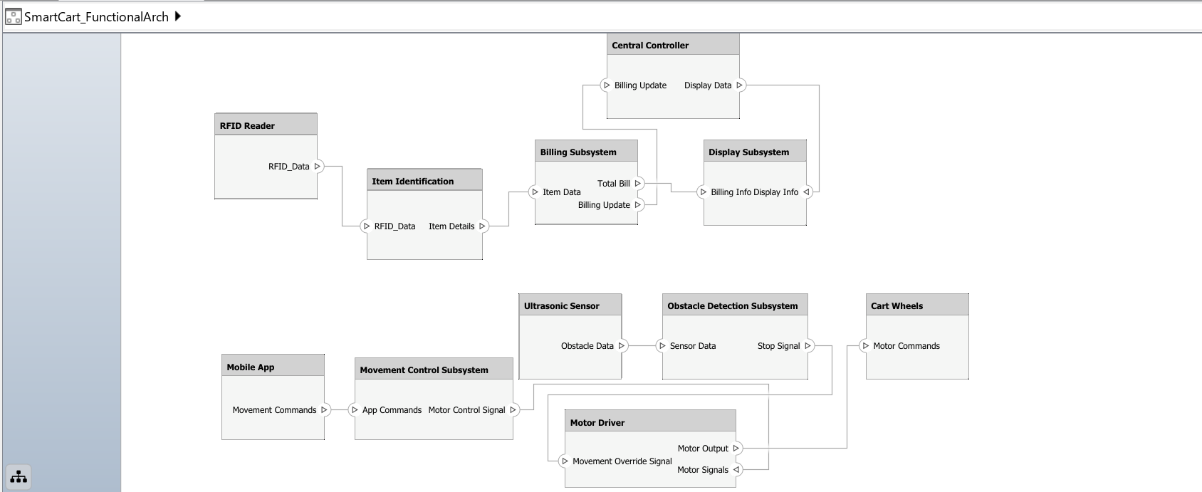

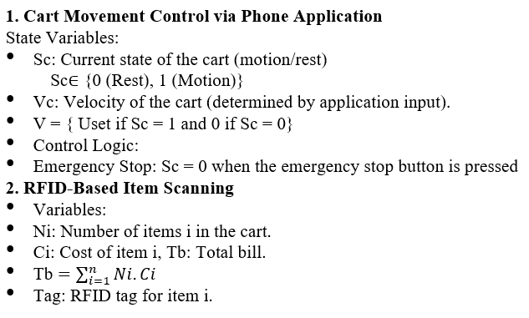**5. 4 Mathematical model** 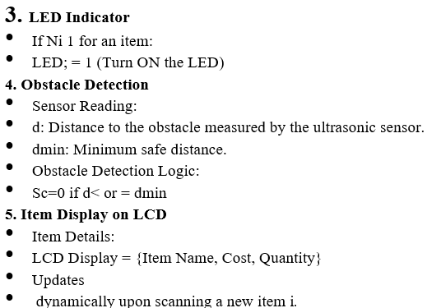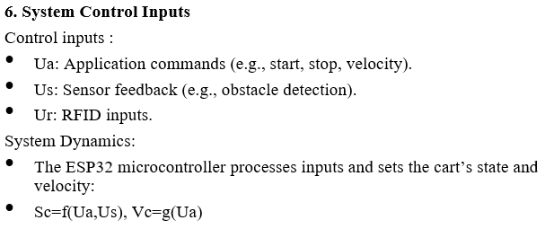

**5. 5. Control system design**

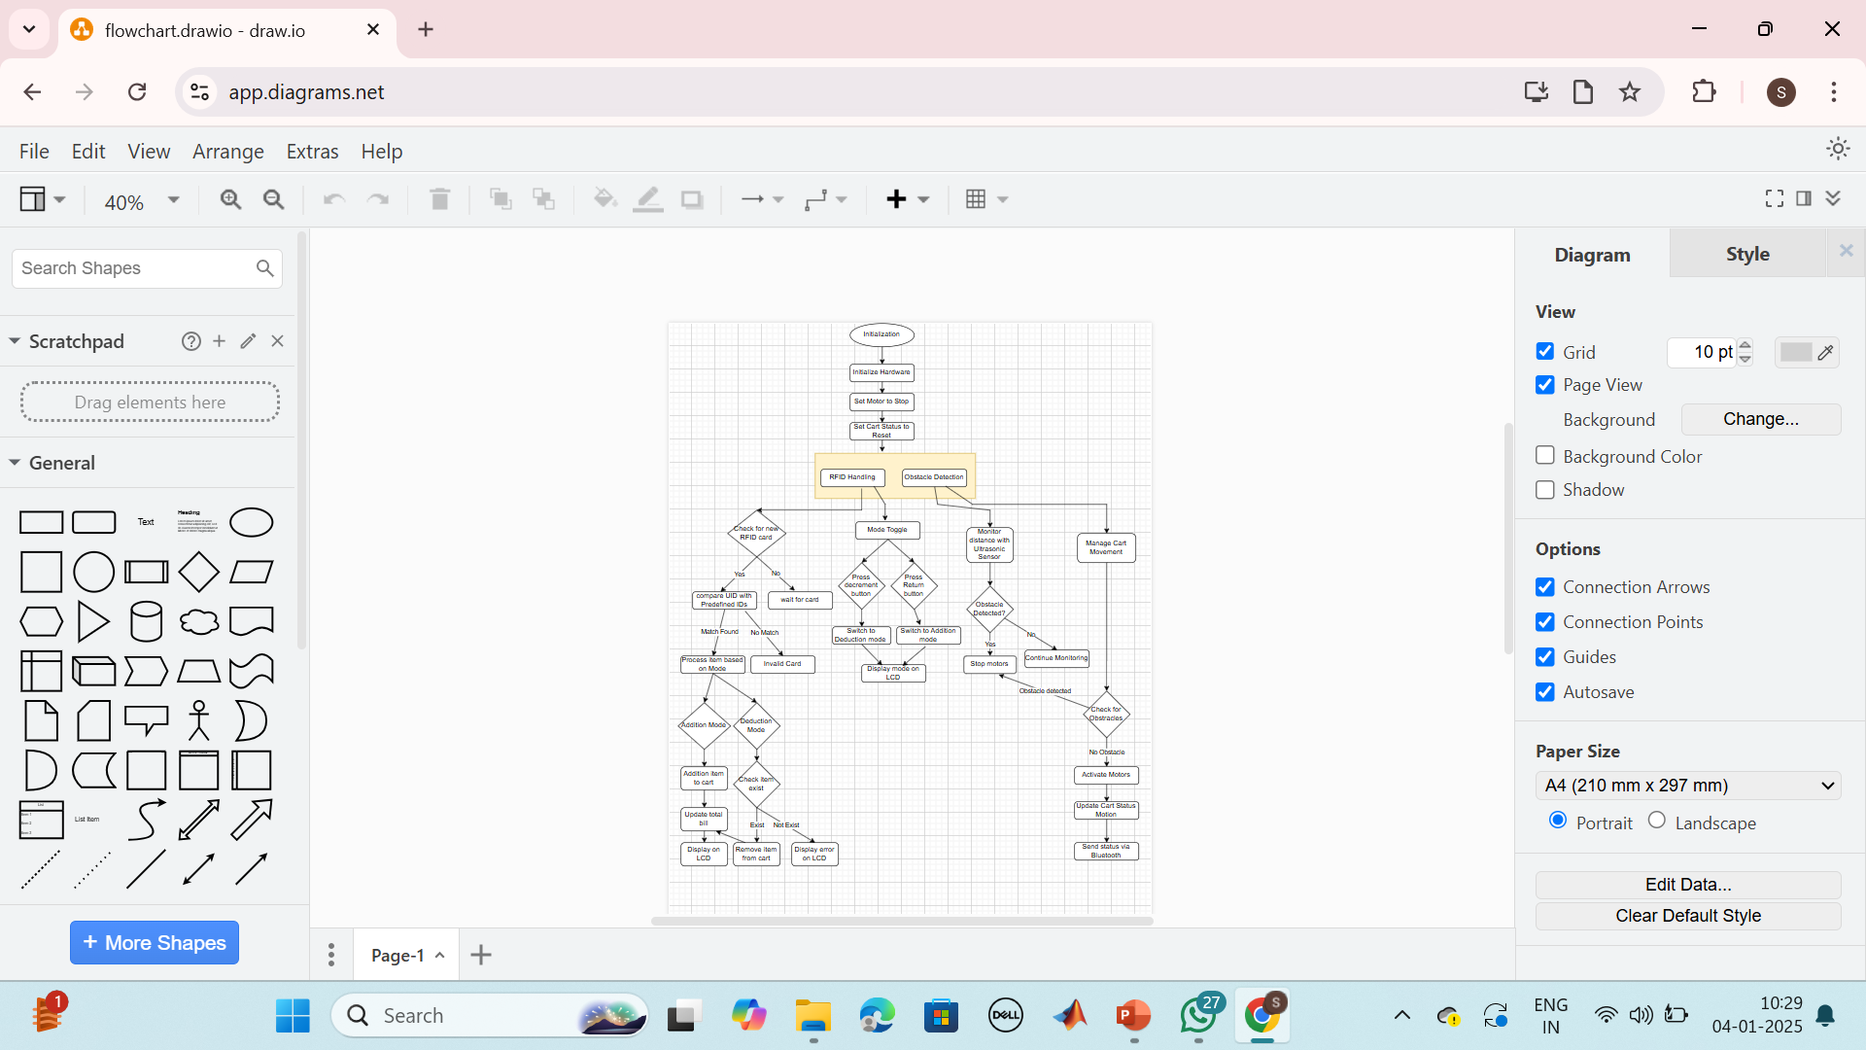

**5. 6. Software design**



* 1. **Electrical Design**

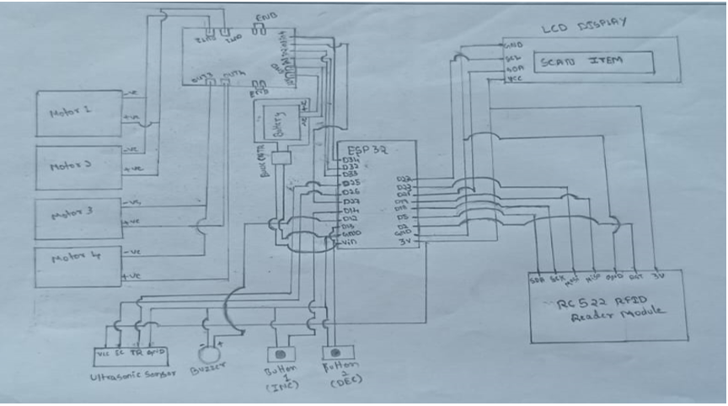

* 1. **Calculations**

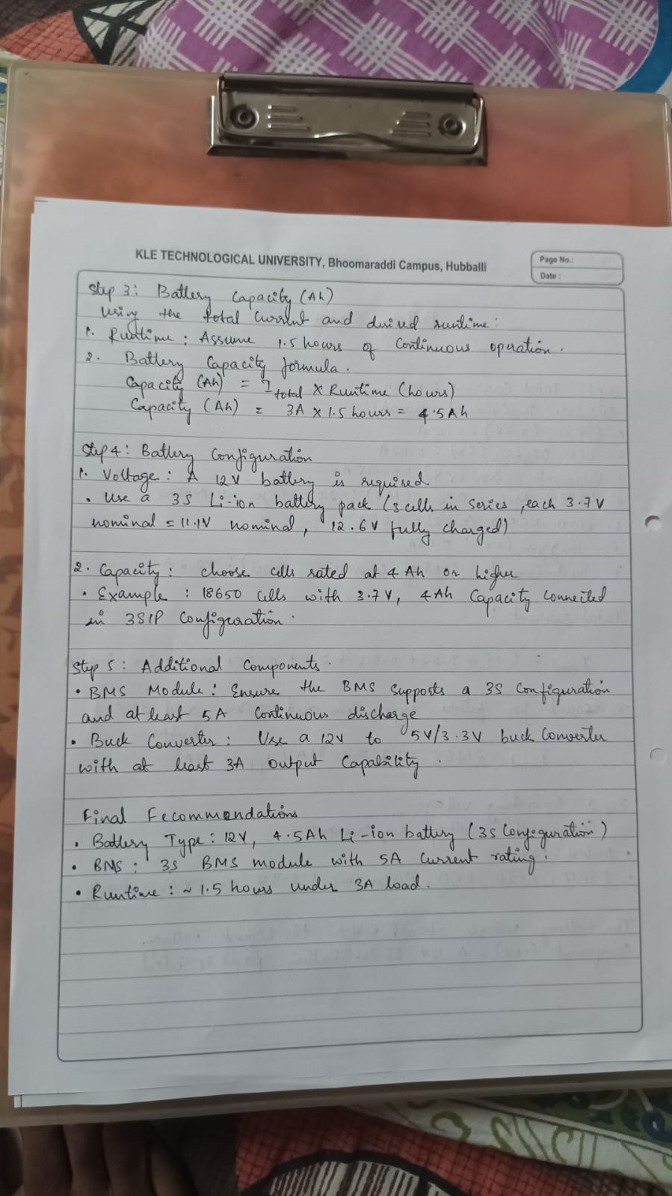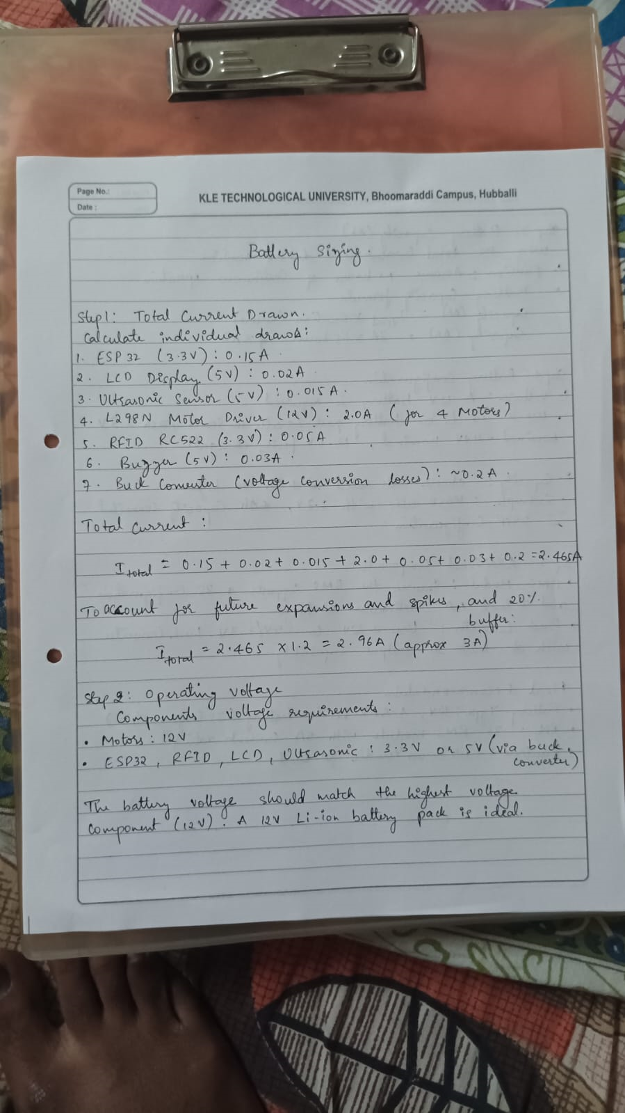 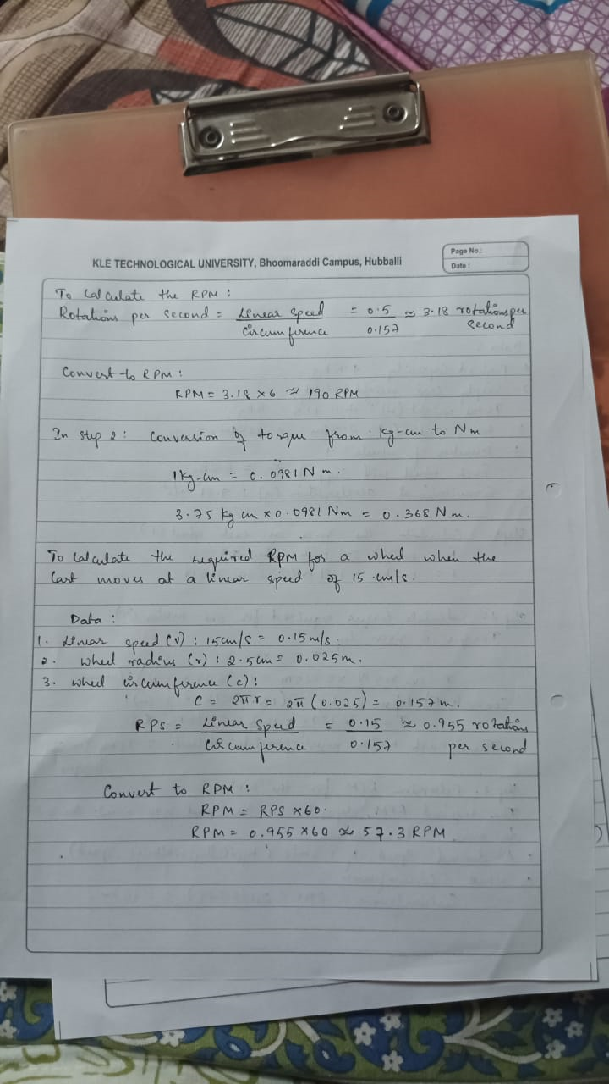

**5. 9 Testing/ Feedback**

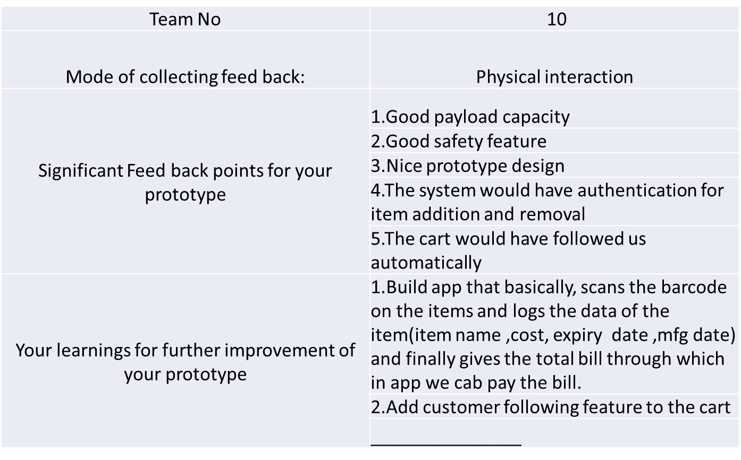

* + 1. **NPS score**

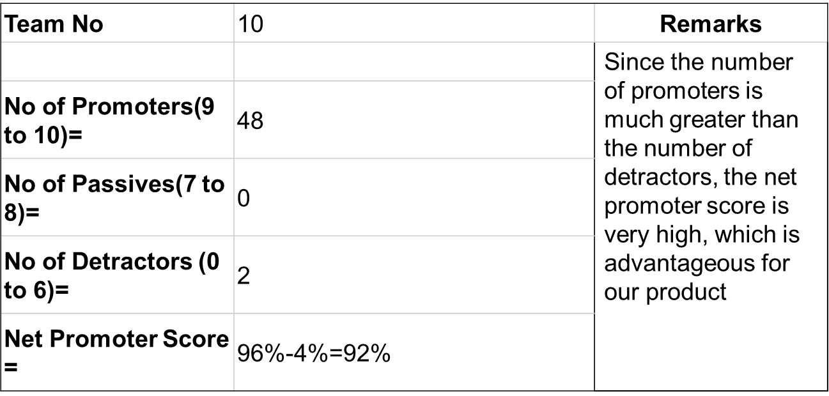

# 6. CONCLUSIONS AND FUTURE WORK

## Conclusions

The development of the **Smart Shopping Cart** integrates automation, IoT, and intelligent tracking to enhance the shopping experience by reducing manual effort. The cart's movement is controlled via a **mobile application**, allowing users to navigate it without manual pushing. Additionally, the cart is equipped with an **obstacle detection system,** ensuring it automatically stops when an object is detected. This system enhances safety and usability, especially for **elderly, disabled, and pregnant customers**, making shopping more accessible and efficient.

By following a structured engineering approach based on the **VDI 2206 model**, the project was systematically developed, from conceptualization to implementation. The iterative nature of this model enabled continuous improvements in both hardware and software integration. Through rigorous testing, the system's functionalities including **motion control, automatic billing via RFID, and real-time obstacle detection** were verified and validated.

This project lays the groundwork for future advancements, such as AI-based customer tracking, enhanced navigation algorithms, and cloud-based data management. The SmartShopping Cart successfully integrates technology to modernize the shopping experience, improving convenience and efficiency while ensuring a user-friendly and safe operation.

## Future Work

Future advancements in the **Smart Shopping Cart** aim to enhance automation, intelligence, and user experience. Implementing **autonomous customer tracking** with AI-based **computer vision** will eliminate the need for manual control, while **advanced obstacle detection** using **LIDAR and depth cameras** will improve navigation. **Cloud integration** can enable real-time data storage, providing **personalized recommendations and predictive analytics**. Additionally, **multi-cart coordination** through **IoT-based communication** can optimize movement in crowded supermarkets. Seamless transactions can be achieved by integrating **digital wallets and NFC payments**, while **energy-efficient power management** using **solar panels and optimized batteries** can improve sustainability. Finally, **voice commands and gesture-based control** will offer a more user-friendly shopping experience, making the cart **smarter, safer, and more efficient**.

**BIBLIOGRAPHY**

1. Bello-Salau, H., Onumanyi, A. J., Michael, D., Isa, R., Alenoghena, C. O., & Ohize, H. (2021). A new automated smart cart system for modern shopping centres. Bulletin of Electrical Engineering and Informatics, 10(4), 2028-2036L. Stein, “Random patterns,” in Computers and You, J. S. Brake, Ed. New York: Wiley, 1994, pp. 55-70.
2. Peradath, A. N. J. A. L. I., Purushothaman, A. N. I. A. L. I., Gopinath, A. N. J. A. N. A., Km, A. N. U. S. R. E. E., & Joe, N. (2017). RFID based smart trolley for supermarket automation. International Research Journal of Engineering and Technology, 4(7), 1975-1980.L. Liu and H. Miao, "A specification-based approach to testing polymorphic attributes," in Formal Methods and Software Engineering: Proceedings of the 6th International Conference on Formal Engineering Methods, ICFEM 2004, Seattle, WA, USA, November 8-12, 2004, J. Davies, W. Schulte, M. Barnett, Eds. Berlin: Springer, 2004. pp. 306-19.
3. Meghana, T. K., Bedare, R. S., Ramakrishna, M., Vignesh, P., & Pavithra, M. (2020). Smart shopping cart with automated billing system. International Journal of Engineering Research & Technology, 8(11), 88-91.
4. Devi, K. G., Kaarthik, T. A., Selvi, N. K., Nandhini, K., & Priya, S. (2017). Smart shopping trolley using RFID based on IoT. International Journal of Innovative Research in Computer and Communication Engineering, 5(3), 5392-5398.
5. Kamble, S., Meshram, S., Thokal, R., & Gakre, R. (2014). Developing a multitasking shopping trolley based on RFID technology. International Journal of Soft Computing and Engineering (IJSCE), 3(6), 2231-2307.